
Citizenship, Economics and Society
(Secondary 1-3)
Support Resources
Secondary 3

Module 3.2
Overview of Our Country’s Economy and World Trade
Part 1:
Economic Performance of Our Country
Personal, Social and Humanities Education Section
Curriculum Development Institute
Education Bureau

Introduction

- The “Citizenship, Economics and Society (Secondary1-3) Support Resources” covers the essential learning contents of Strands 1, 5 and 6 in the Personal, Social and Humanities Education Key Learning Area. It is designed to support the implementation of the Citizenship, Economics and Society curriculum.
- The support resources provide diversified learning activities to help students acquire knowledge and understand concepts, develop skills and nurture proper values and attitudes. In addition, they offer teaching guidelines and suggestions on learning and teaching activities for teachers’ reference. Further, they provide reading materials to enhance students’ interest in reading.
- “Module 3.2: Overview of Our Country’s Economy and World Trade Part 1: Economic performance of our country” for Secondary 3 was developed by the Personal, Social and Humanities Education Section, Curriculum Development Institute of the Education Bureau. Part of the contents are based on the learning and teaching materials developed by the Business School of the Chinese University of Hong Kong and Hong Kong Effective Teaching Association, commissioned by our section in 2019 and 2014 respectively.

Module 3.2 Overview of Our Country’s Economy and World Trade
Part 1: Economic Performance of Our Country
Contents

 | Page
Introduction | 4
Teaching Design
Lesson 1 to Lesson 4: Economic performance and achievements of our country | 5
Lesson 5 to Lesson 7: Impacts of economic development of our country on the livelihood of Chinese residents | 8
Learning and Teaching Activities
Lead-in Activity: Why do we need to understand the economy of our country? | 11
Worksheet 1: Economic performance of our country | 14
Worksheet 2: Unemployment rate and the consumer price index of our country | 18
Worksheet 3: Industrial structure of our country | 21
Worksheet 4 The lifestyle of Chinese residents | 28
Case Study: Guizhou Province | 38
Self-learning material
Online Learning Resources | 35
References | 42

Introduction
This resource aims to give students an overview of the country’s economy from a macro perspective. On the basis of what they have learned in module 2.4 “Economic Performance and Human Resources of Hong Kong”, students will use their data and graphical analysis skills to compare the relevant economic data of the Mainland with those of other countries, so as to understand the level of economic development of our country among other economies in the world, and the changes and trends of our country’s industrial structure and labour force structure since reform and opening up. In addition, students will briefly understand how the livelihood of Chinese residents in urban and rural areas has benefited from the economic development of our country and improved greatly, as well as the achievements of the country’s policies in improving people’s livelihoods (e.g. poverty alleviation policies), and be proud of the growing prosperity of our country.

Prior Knowledge
Students have acquired basic knowledge about the economy of our country at the primary level. In General Studies, they have learned relevant contents including “recent development of China (e.g. economic and technological aspects)”, “linkage between China and other parts of the world” and trade between Hong Kong, the Mainland and other parts of the world. In addition, students have also become familiar with some common indicators for measuring economic performance and the classification of industrial structure (including the definitions of primary, secondary and tertiary industries).

Teaching Objectives
- To understand the knowledge related to the economic development of our country
- To develop and nurture relevant generic skills, values and attitudes

Learning Points
- Understand the level of economic development and achievements of our country
- Recognise the changes and trends of our country’s industrial structure and labour force structure since reform and opening up
- Understand how the livelihood of Chinese residents has greatly improved due to economic development of our country, and the achievements of our country’s policies to improve people’s livelihood (e.g. poverty alleviation policies)

Suggested Number of Lessons
- 7 lessons (40 minutes each)

Teaching Design
Topic: | Economic performance of our country
Duration: | 7 lessons
Learning Objectives: | - To understand the level of economic development and achievements of our country  - To recognise the changes and trends of our country’s industrial structure and labour force structure since reform and opening up  - To understand how the livelihood of Chinese residents has greatly improved due to economic development of our country, and the achievements of our country’s policies to improve people’s livelihood (e.g. poverty alleviation policies)
Lesson 1 to Lesson 4 (Economic performance and achievements of our country)
Lesson 1 and Lesson 2
 |  | Suggested lesson time
Enquiry process: | - Set:  - The teacher introduces the contents of these seven lessons, and through the “Lead-in Activity: Why do we need to understand the economy of our country?” lets students understand our country’s economic development in recent years and think about its relationship with Hong Kong. | 10 minutes
Enquiry process: | - Interactive teaching:  - Review the definitions of various indicators for measuring economic performance.  - The teacher guides the students to complete the questions in “Worksheet 1: Economic performance of our country” and then elaborates on related contents based on students’ answers. | 35 minutes
Enquiry process: | - Interactive teaching:  - The teacher asks the students to complete the questions in “Worksheet 2: Unemployment rate and the Consumer Price Index of our Country” and then elaborates on related contents based on students’ answers.  (Remark: The teacher may discuss the challenge question “Do you know the reasons for the changes in our country’s unemployment rate and urban consumer price inflation rate between 2008 and 2009?” with students according to their interests, abilities, and prior knowledge.) | 25 minutes
Enquiry process: | - Conclusion:  - Teachers summarises what students have learned in class and ask them to read “Worksheet 3: Industrial structure of our country” at home as pre-lesson preparation. | 10 minutes
Homework: | Students read “Worksheet 3: Industrial structure of our country” at home.
Learning and Teaching Resources | Worksheets 1 and 2

Lesson 3 and Lesson 4
Pre-class preparation: | Teachers distributes “Worksheet 3: Industrial structure of our country” before class and ask students to read it at home as pre-lesson preparation.
 |  | Suggested lesson time
Enquiry process: | - Set:  - Teacher reviews the definitions of the three industries with students by explaining the content of Source 1 of “Worksheet 3: Industrial structure of our country”. | 10 minutes
Enquiry process: | - Interactive teaching:  - The teacher guides students to complete Questions 1 to 4 of “Worksheet 3 Industrial structure”, and then elaborates on related contents according to the students’ answers.  (Remark: The teacher may discuss the challenge question “Do you think our country can only develop secondary and tertiary industries?” with students according to their interests, abilities and prior knowledge.) | 45 minutes
Enquiry process: | - Interactive teaching:  - By explaining the content of “Know More: Food security”, the teacher discusses with the students how our country deals with the food problem. | - minutes
Enquiry process: | - Summary:  - The teacher summarises what students have learned in class to help students develop a general understanding of our country’s economic performance and achievements. | 10 minutes
Learning and Teaching Resources: | Worksheet 3; Appendix 1

Lesson 5 to Lesson 7 (Impacts of economic development of our country on the livelihood of Chinese residents)
Lesson 5 and Lesson 6
 |  | Suggested lesson time
Enquiry process: | - Set:  - The teacher shows students some photos of China before and after its Reform and Opening up, for example “China Daily – Comparison of 40 Years of Reform and Opening Up: China in 1978 VS China in 2018”  (https://language.chinadaily.com.cn/a/201811/23/WS5bf74e82a310eff30328a888_2.html) to let students understand the achievements of the economic development of our country. | 10 minutes
Enquiry process: | - Interactive teaching:  - The teacher asks students to complete Questions 1 to 2 of “Worksheet 4: Lifestyle of Chinese Residents”, and then elaborates on related contents based on students’ answers. | 25 minutes
Enquiry process: | - Interactive teaching:  - The teacher asks the students to complete Questions 3 to 4 of Worksheet 4, and then elaborates on related contents based on students’ answers.  (Remark: The teacher may discuss the challenge question “Based on the above information, analyse the changes in the living standards of urban and rural residents in the country over the past two decades.” with students according to their interests, abilities, and prior knowledge.) | 25 minutes
Enquiry process: | - Online learning:  - The teacher asks the students to browse some photos online, for example, the China Net: China’s National Conditions [Development Photo Album]  (http://guoqing.china.com.cn/node_8007707.htm) to learn about the consumption patterns, travel patterns, changes in living environments, medical care, etc. of Chinese residents in urban and rural areas. | 10 minutes
Enquiry process: | - Summary  - The teacher summarises what students have learned in class, and asks them to read “Examples of national policies for improving people’s livelihood: Poverty alleviation policies” at home as pre-lesson preparation. | 10 minutes
Homework: | Students read “Examples of national policies for improving people’s livelihood: Poverty alleviation policies” at home.
Learning and Teaching Resources | Worksheet 4

Lesson 7
 |  | Suggested lesson time
Enquiry process: | - Set:  - The teacher plays a short video about the poverty alleviation policy of China, for example, “China Today EP 17- How China has lifted people out of poverty”  (https://www.youtube.com/watch?app=desktop&v=QjTgj0mNAUA), and briefly explains our country’s targeted poverty alleviation policy to students. | 10 minutes
Enquiry process: | - Interactive teaching:  - The teacher guides students to read “Case Study - Guizhou Province” and Source 1 and asks them to answer Question 1, and then elaborates on related contents according to the students’ answers.  - The teacher asks students to watch the different videos in Source 2 in groups and complete Questions 2 and 3 based on the video contents and the online information, and then report the answers to the whole class. | 20 minutes
Enquiry process: | - Summary:  - The teacher summarises what students have learned in class, and let them understand how our country’s economic development has greatly improved the livelihood of Chinese residents, and the achievements of our country’s policies of improving people’s livelihood (such as poverty alleviation policies). | 10 minutes
Learning and Teaching resources: | Case study

Module 3.2 Overview of Our Country’s Economy and World Trade
Part 1: Economic Performance of Hong Kong
(Lesson 1 and Lesson 2)
Learning and Teaching Materials

Lead-in Activity: Why do we need to understand the economy of our country?
This Lead-in Activity can help students understand the economic development of our country in recent years, and also helps the teacher understand about students’ prior knowledge (e.g. “Gross Domestic Product”, “three strata of industry”).
Leon, we are going to graduate from university next year. I am thinking of pursuing a career in the arts. Do you have any plans?


I am studying economics and finance at university, and I plan to look for job opportunities in the Mainland after graduation because our country is already the second largest economy in the world in terms of GDP since 2010. In recent years, the economic structure of the Mainland has gradually moved away from relying on the secondary industry to actively developing the tertiary industry. Commerce, industry, finance, and infrastructure are all developing rapidly. In addition, the Mainland market is also much larger than that of Hong Kong. Therefore, the potential for future development will be great, and there will be more job opportunities. Furthermore, I think that working in the Mainland can increase my knowledge and enhance my competitiveness.
Yes, on the other hand, the Central Government has been vigorously developing the Guangdong-Hong Kong-Macao Greater Bay Area and encouraging division of labor within the region and between cities. Now, many Hong Kong people are considering retiring or buying property in the Mainland cities in the Greater Bay Area. Increasingly more Hong Kong people are also looking for learning and career opportunities in the Mainland. It has become a trend.

We all need to prepare for the future. In addition to understanding the economic situation in Hong Kong, we also need to have a general understanding of the basic economic situation in the Mainland so that we can broaden our horizons and have more choices.

Think about it:
- Can you name some industries that have flourished in the Mainland in recent years? Do these industries belong to the primary industry, secondary industry, or tertiary industry?
- Compared with Hong Kong, is the industrial structure in the Mainland the same as that in Hong Kong?
- What economic indicators can we use to measure our country’s economic performance?
Teaching Tips:
Students have acquired a preliminary understanding of the basic knowledge of various indicators for measuring economic performance and the definitions of the three strata of industry. On this basis, they can apply data and graphical analysis skills to compare data from the Mainland and other countries.


Revisiting Concepts

Gross Domestic Product
Gross Domestic Product (GDP) is the total value of goods and services produced in a country or region over a specified period of time. GDP is a commonly used indicator that measures the economic situation of a place.

Per capita Gross Domestic Product
Per capita Gross Domestic Product (per capita GDP) is calculated by dividing the GDP by the total population. It can reflect the average income of the people of a place.

Unemployment Rate
The unemployment rate refers to the proportion of unemployed population in the labour force, which can reflect the labour market situation and economic performance of a place.

Consumer Price Index
The consumer price index (CPI) measures changes in the price level of consumer goods and services purchased by households over time. When the CPI increases, its means the general price level and cost of living increase, and vice versa.

Inflation Rate / Deflation Rate
Inflation refers to the phenomenon of a persistent increase in the general price level. Deflation refers to the phenomenon of a persistent decrease in the general price level

The year-on-year percentage change in the consumer price index (CPI) can be used to measure inflation and deflation, that is, the inflation rate / deflation rate. This indicator can reflect changes in the general price level as well as the cost of living. For example, the inflation rate of 2021 can reflect how much the price level in 2021 is higher or lower than the price level in 2020.

$$Inflatoin rate = \frac{P_{2021}-P_{2020}}{P_{2020}}×100\%$$
$$P_{2020}: CPI in 2020$$
$$P_{2021}: CPI in 2021$$

Worksheet 1: Economic performance of our country
Our country began to implement reform and opening up in 1978 and has achieved remarkable achievements in economic development in the past few decades.

Source 1: Economic performance of our country in 1978

In 1978, China’s GDP was only US$149.5 billion, ranked 11th in the world. According to the World Bank, China was ranked 134th out of 146 countries in 1978 in terms of per capita GDP of US$156. The level of economic development of our country was quite low at that time.
.

Source 2︰Our country’s economy has been growing steadily

In 2000, China’s GDP was $1,211.3 billion and per capita GDP was US$959, ranked 6th and 135th respectively in the world. Compared to 1980, the GDP had increased by six times, while the per capita GDP had increased by as much as five times. During these 20 years, our country’s economy has grown significantly.

Source 3: Our country’s GDP ranked second in the world in 2011
According to the data released by the World Bank, in 2011, China’s GDP was US$7,551.5 billion, ranked second in the world after the United States. In the eleven years from 2000 to 2011, China’s GDP rose from sixth to second place in the world, surpassing many developed countries. The development pace of our country was quite amazing. However, while the GDP had continued to rise, the per capita GDP was only US$5,618, ranked 84th in the world.



Source 4: The economic performance of China in 2021

According to the World Bank’s data, in 2021, China’s GDP was US$17,734.06 billion and its per capita GDP was US$12,556. Compared to forty years ago when I first joined the workforce, the economy had indeed grown a lot!

:
Source: The World Bank (2022), GDP (current US$). https://data.worldbank.org.cn/indicator/NY.GDP.PCAP.CD

Answer the following questions according to the above information.
- Refer to the above information, fill in the data on China’s economic performance from 1978 to 2021.
 | 1978 | 2000 | 2011 | 2021
GDP (billion US$) | 149.5 | 1211.3 | 7551.5 | 17,734.1
Per capita GDP(US$) | 156 | 959 | 5,618 | 12,556

- Based on the above data, try to describe the changes in China’s economic performance from 1978 to 2021.
GDP and per capita GDP are indicators of a country’s economic performance.
As indicated by the data, China’s GDP and per capita GDP had increased
significantly from 1978 to 2021. In 1978, China’s GDP was US$149.5
billion, while the per capita GDP was US$156. By 2021, China’s GDP
was US$17,734.1 billion, ranked second in the world, and its per capita GDP
was US$12,556. These two figures reflect that China's economy had improved
significantly over the years.

- What changes does the rise in GDP reflect in people’s living standards?
A rise in GDP means that the overall income of the people increases,
and the services and products available to the public increase.
The figures show that there was improvement in the quality of life. However, it
should also be noted that these figures do not reflect all aspects, such as whether
the distribution of income is even and the inflation situation.

The table below shows economic data of China and other places in 2019:
Country/ Region | GDP ranking | GDP  (US$ billion) | Per capita GDP(US$) | Total population (billion)
USA | 1st | 21,433.2 | 65,298 | 0.33
The Chinese Mainland | 2nd | 14,279.9 | 10,200 | 1.40
Japan | 3rd | 5,081.8 | 40,247 | 0.13
Germany | 4th | 3,861.1 | 46,468 | 0.08
South Korea | 12th | 1,646.7 | 31,846 | 0.05
Singapore | 34th | 372.1 | 65,233 | 0.006
Hong Kong, China | 35th | 365.7 | 48,714 | 0.008

Source：The World Bank (2020), GDP (Current USD). 29 April 2021
https://data.worldbank.org.cn/indicator/NY.GDP.MKTP.CD?view=chart
https://data.worldbank.org.cn/indicator/NY.GDP.PCAP.CD

- Based on the above table, compare the economic size (i.e. the size of GDP) of China and those of other economies listed in the table.
As shown in the table above, China’s GDP, reflecting its economic size, was
ranked among the top in the world. In 2019, China’s GDP was second only to
that of the United States and higher than those of countries with higher levels of
economic development, such as Japan, Germany, and South Korea.

- Calculate the per capita GDP of China and fill in blank space in the table. Compare and explain the average income of people in China and those of other places in the table.
As shown in the table above, although China’s GDP was ranked second in the
world, its per capita GDP was lower than those of all other countries/regions
because China’s population was much larger. Its GDP per capita remained well
below those of some developed countries/regions in Asia, Europe, and the United
States, indicating that people in the Mainland enjoyed fewer goods and services
on average than people in other developed countries/regions.

- Which indicator (GDP or per capita GDP) do you think can more accurately reflect our quality of life?
Per capita GDP.
GDP does not take into account the population size. For the same GDP, the larger
the population,the lower the per capita GDP. Therefore, a higher GDP does not
imply a higher output per capita or a higher standard of living.

- Do you know any other indicators of economic performance?
Unemployment rate and inflation rate.
(or other appropriate answers)

Worksheet 2: Unemployment rate and the consumer price index of our country

Source 1: Registered unemployment rate in urban area, 2002-2021
Source: “Unemployment Rate in Urban Area”, National Bureau of Statistics of China, 2021 https://data.stats.gov.cn/english/easyquery.htm?cn=C01

- Based on Source 1, describe the changes in China's registered unemployment rate in urban area from 2002 to 2021.
The registered unemployment rate in urban area rose slightly from 2002 to 2003,
remained stable from 2004 to 2015, declined from 2015 to 2019, and rose in 2020
and 2021 due to the impact of the epidemic.

Source 2: The urban consumer price inflation rate, 2002-2020

Source: “Price Indices”, China Statistical Yearbook 2021, National Bureau of Statistics (2021) http://www.stats.gov.cn/tjsj/ndsj/2021/indexeh.htm
[Remark: The urban consumer price inflation rate is calculated from the urban consumer price index. The urban consumer price index reflects the trend and degree of changes in the prices of consumer goods and services purchased by urban households within a certain period of time.]

- Based on Source 2, which years did the Mainland experience deflation?
The Mainland experienced deflation in 2002 and 2009, that is, the phenomenon
of a continuous decline in the general price level.

- Based on Source 2, in which years did the people in the Mainland have a higher living cost than those of other years?
The inflation rates in 2008 and 2011 were 5.6% and 5.3% respectively, reflecting
that the costs of living in these two years were higher than those of other years.

- Challenge question: Do you know the reasons for the changes in the unemployment rate and urban consumer price inflation rate between 2008 and 2009 in our country?
Tip: You can refer to Module 2.4, “Hong Kong’s Economic Performance and Human Resources” for information on events that had occurred overseas in the past ten years.)

The global financial crisis occurred in late 2008, leading to an economic
recession around the world, including China. At that time, the reduction in
demand for imported goods in various places had a major impact on China’s
exports, resulting in a rapid shrinkage of our country’s industrial production and
a slight increase in the unemployment rate in 2009. Due to the economic
recession, income of the general public fell, and both consumption and
investment declined, resulting in a sharp drop in the price level to
negative figures in 2009.

Module 3.2 Overview of Our Country’s Economy and World Trade
Part 1: Economic Performance of Hong Kong
(Lesson 3 and Lesson 4)
Learning and Teaching Materials

Worksheet 3: Industrial structure of our country
Source 1: Classification of three types of industries

Teacher, the GDP of our country was ranked second in the world last year, which is really good!

So, do you know which industry contributes the most to the country’s GDP?

Industry? I know that there are three types of industries, namely primary industry, secondary industry, and tertiary industry. But I’m not sure how to distinguish them.

Then take a look at the following information:
According to the “Regulations on the Classification of Three Industries” of the National Bureau of Statistics, the primary industry is agriculture, forestry, animal husbandry, and fishery; while the secondary industry refers to mining, manufacturing, the production and supply of electricity, heat, gas, and water, and construction industry. The tertiary industry, namely the service industry, refers to industries other than the primary industry and the secondary industry.

Source: “三次產業劃分規定”, National Bureau of Statistics (2019)

- According to the above information, indicate whether the following people are engaged in the primary industry, secondary industry or tertiary industry?
- Workers in factories producing mobile phones | Secondary industry
- A receptionist who assists with guest registration at the hotel counter | Tertiary Industry
- Farmers growing rice in rural Guizhou | Primary industry
- The manager of a convenience store in Shenzhen | Tertiary Industry
- A teacher of a middle school in Beijing | Tertiary Industry
- Porters in Mainland supermarkets | Tertiary Industry
- Tailors working in garment factories | Secondary industry
- Fishermen who make a living from fishing in Fujian | primary industry

Source 2: The development of our country’s industries after the reform and opening up

In the early years of reform and opening up, our country’s agricultural foundation was weak, the industrial structure was unbalanced, and the development of the service industry was lagging behind. With the continuous advancement of the industrialisation process, a modern industrial system with complete industrial categories and a balanced structure has gradually formed, and China has become the world’s top manufacturing country. In recent years, the country has implemented a series of major policy measures to speed up the development of the service industry. The tertiary industry has continued to develop rapidly and the proportion of added value has continued to increase.
Source: “經濟結構實現歷史性變革 發展協調性顯著增強——改革開放40年經濟社會發展成就系列報告之二”, National Bureau of Statistics (2018)
Source 3: China’s composition of GDP by the three strata of industry (%) in 1978, 2000, 2009 and 2021

Source: Composition of GDP by the three strata of industry, GDP (%), National Bureau of Statistics (2021)
Source 4: Percentage of employed persons at year-end by three strata of industry, 1978-2020
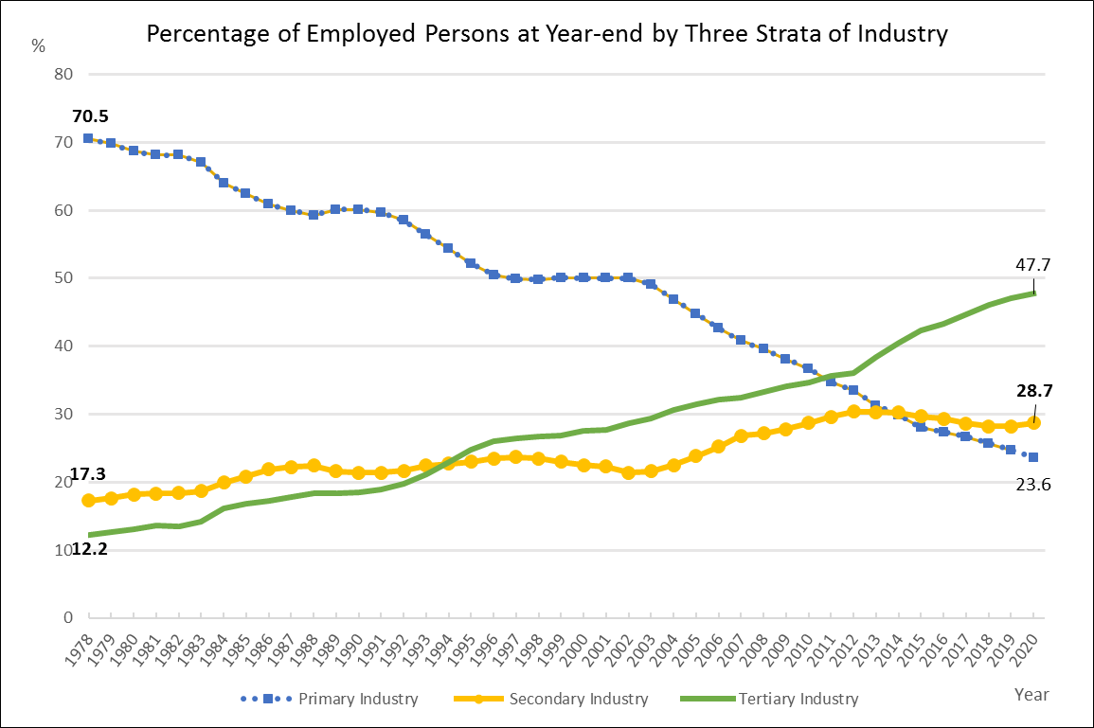
Tertiary industry
Secondary Industry
Primary Industry
Source: “4-2 Number of Employed Persons at Year-end by Three Strata of Industry” China Statistical Yearbook 2021, National Bureau of Statistics (2021)

- Based on Sources 3 and 4, analyse how the relative importance of various industries to the national economy has changed.

(i) Briefly describe the changes in each industry from 1978 to recent years in the table below.

Industry | % of GDP | % of total employment
Primary industry | Decreased from 9.8% in 1978 to 6.7% in 2021 | Decreased from about 70% in 1978 to about 24% in 2020
Secondary Industry | Decreased from 61.8% in 1978 to 38.4% in 2021 | Increased from about 17% in 1978 to about 29% in 2020
Tertiary Industry | Increased from 28.4 % in 1978 to 54.9% in 2021 | Increased from about 12% in 1978 to about 48% in 2020

(ii) Calculate and compare the ratios of the secondary and tertiary industries to total employment in 1978 and 2020.
In 1978, employees working in the secondary and tertiary industries
together accounted for 29.5% of the total employment. By 2020, the
employees working in the secondary and tertiary industries together
accounted for 93.3% of the total employment, more than a twofold increase.

(iii) According to Sources 3 and 4, do you think China is still an agricultural society? Please explain your answer.
According to the above information, China is no longer an agricultural
society because agriculture is the primary industry, and the output
value of the primary industry accounts for less than 10% of its GDP, and
the proportion of the total employees is also less than 25%, which is
declining. It is the least developed of the three strata of industry.

- Based on the above information, determine the relative importance of agriculture, manufacturing, and service industries in our country’s economy.
From 1978 to 2021, the percentage of the primary industry in our country’s GDP
and the proportion of its employees had dropped significantly, reflecting the
diminishing contribution and relative importance of agriculture to our country’s
economy.
As far as the secondary and tertiary industries are concerned, the proportion of
employees in the secondary industry had increased by 65% (from 17.3% to
28.7%),and the proportion of employees in the tertiary industry had increased
by four times (from 12.2% to 47.7%). These reflect that the relative importance
of secondary and tertiary industries in 2021 is higher than that of 1978.
Remarks: (Advanced answer) Recent year data reflect that from 1978 to
2021, the percentage of the secondary industry in our country’s GDP had been
gradually decreasing, reflecting the relative importance of the manufacturing
industry had declined; while the percentage of the tertiary industry in the GDP
had continued to rise, reflecting the increasing importance of the service industry.

- Try to guess which industry our country will devote itself to developing in the next ten years. Why?
Our country will devote to developing the secondary and tertiary industries
in the future, especially some high-tech and high value-added industries, so as
to meet the needs of our country’s sustainable economic development in the
future.

- Challenge question: Do you think our country can only develop secondary and tertiary industries?
Our country cannot ignore the development of its primary industry. Although
the contribution of the secondary and tertiary industries to the GDP is relatively
important, the primary industry can still provide jobs in rural areas. Although
the proportion of labor employed is smaller than that of the other two industries,
it was still close to 25% in 2021, so China cannot ignore the primary industry.
Another feasible answer: China cannot ignore the development of its primary
industry. Since the three industries are interdependent and agriculture is a
strategic industry, China still needs to provide food for a population of nearly
1.4 billion people population and raw materials for the secondary and tertiary
industries, so it needs to pay attention to the balance of the development of the
industries.


Appendix 1

Know More: Food security
The United Nations published the 2022 Global Food Crisis Report on 4 May 2022. According to the report, in 2021, nearly 193 million people around the world were severely food insecure, an increase of nearly 40 million from the previous year. Regional conflict, extreme weather, and economic crises are the main reasons for the deterioration of the global food security situation. The Russia-Ukraine conflict has caused global food prices to soar, with serious consequences for global food and nutrition security. The United Nations has called for urgent action to prevent and alleviate famine and collectively address serious food insecurity at the global level.
Source: UN News, 4 May 2022
https://news.un.org/zh/story/2022/05/1102642

How does our country deal with the food problem?
In recent years, China’s grain production has been stable, and the supply is abundant, which can meet the overall demand. In 2021, China’s grain harvest was 683 million tons, a year-on-year increase of 2%. The Chinese people are completely self-sufficient in terms of food. The self-sufficiency rate of China's grains, especially wheat and rice, has reached 98% all year round. Including corn, China's grain self-sufficiency rate reached 96% in 2021, and China’s grain reserves reached 18% of annual consumption.
Source: Think HK, Secrets of China’s Granary, 6 June 2022,
https://www.thinkhk.com/article/2022-06-06/55385.html

Module 3.2 Overview of Our Country’s Economy and World Trade
Part 1: Economic Performance of Hong Kong
(Lesson 5 and Lesson 6)
Learning and Teaching Materials

Worksheet 4: Lifestyle of Chinese residents
In the previous part, we have learned that our country’s economy has grown rapidly since the reform and opening up. Since 2011, the country has become the second largest economy in the world in terms of its GDP. The following section will look at how the lives of urban and rural residents in the Mainland have benefited from our country’s economic development and have been greatly improved in the past forty years in terms of work, income, and consumption patterns.

Source 1: Changes in the percentage of employment in the three strata of industry in Beijing, Shanghai, and Guizhou in 2000 and 2020

Source: China Statistical Yearbook (2021) extracted from 4.3 Employed Persons by Region (end of 2020)

  - According to Source 1, briefly compare the changes of the three industries in the three regions between 2000 and 2020 in the following table:
 | Primary Industry | Secondary Industry | Tertiary Industry
Beijing | In Beijing, about 12% of employed persons were engaged in the primary industry in 2000, but this had dropped to only 2.4% in 2020. | In 2000, about 30% of the employed persons were engaged in the secondary industry, but by 2020, this had dropped to only 16.7%. | In 2000, it was the industry with the largest number of people (more than half of the employed people); by 2020, the number of employees had risen to 80.9%, and it continued to be the industry with most employees in Beijing.
Shanghai | In 2000, about 13% of employed persons were engaged in the primary industry, but by 2020, that number had dropped to 2%. | In 2000, about 40% of employed persons were engaged in the secondary industry, but by 2020, that number had dropped to 32.6%. | In 2000, 44.1% of people were engaged in this industry, slightly higher than the percentage of those engaged in the secondary industry; by 2020, the number of people engaged in the tertiary industry had risen to more than 60%, which was significantly higher than the number of people engaged in the secondary industry.
Guizhou | In 2000, more than 60% of the employed population was engaged in the primary industry, which was the industry with the largest number of people employed. But in 2020, the percentage of people engaged in the primary industry had dropped to just over 30%, and this industry had become the one with the second largest number of employees. | In 2000, less than 10% (9.3%) of the employed persons were engaged in the secondary industry, but in 2020, about 25% (24.9%) of the employed persons were engaged in this industry. It was still the industry with the fewest people employed. | In 2000, about 23.4% of the people were employed in the tertiary industry, which was the second largest industry. By 2020, the number of people employed had risen to 41.5%, making it the industry with most people working in it.

  - What common phenomenon does the above analysis reflect in these three regions?
The percentage of people employed in the primary industry in all three regions
had declined over the past 20 years, while the percentage of people employed
in the tertiary industry had increased.


Source 2: Annual average income trends of rural and urban residents from 2000 to 2021
Disposable income of urban residents
Disposable income of rural residents
Year

(Remark: Disposable Income of Residents refers to the income of residents for purpose of final expenditure and savings. It includes income both in cash and in kind. By sources of income, disposable income includes four categories: income from wages and salaries, net business income, net income from properties and net income from transfer.)
Source: China Statistical Yearbook (2021)

Based on the above information, answer the following questions:

  - Try to calculate the change in the income of rural and urban residents between 2000 and 2021. Summarise the data in the table below by briefly describing the changes.
 | Rural area | Urban area
Change in income | $18,931 -$2,282  = $16,649 | $47,412-$6,256  =$41,156
Percentage change in income | ($18,931 -$2,282)/ $2,282 x 100%  =729.6% | ($47,412-$6,256)/$ 6,256 x 100%  =657.9%
The average income of both rural and urban residents had increased
between 2000 and 2021, with the average income of rural residents rising at a
higher rate than that of urban residents.

Along with the development of our country’s economy, the income of urban and rural residents has increased, and their consumption patterns have also changed. Source 3 below shows the changes in the composition of urban and rural per capita expenditure in 2002 and 2021.

Source 3: Changes in the composition of urban and rural per capita expenditure in 2002 and 2021
Composition of per capita expenditure of urban residents in 2002 and 2021 (RMB)
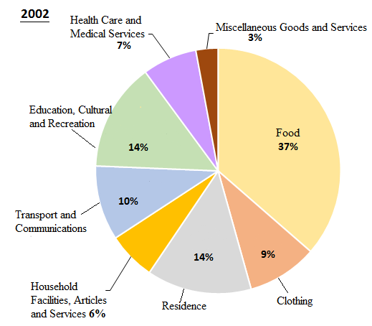 |  |  | 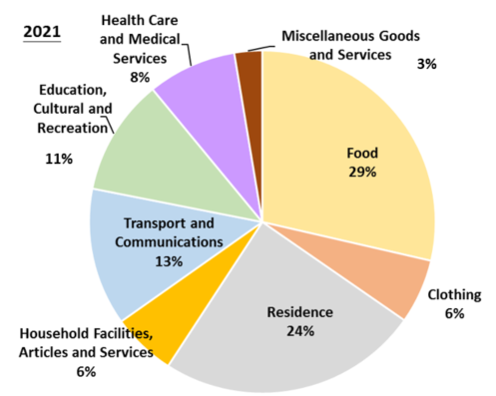

Composition of per capita expenditure of rural residents in 2002 and 2021 (RMB)
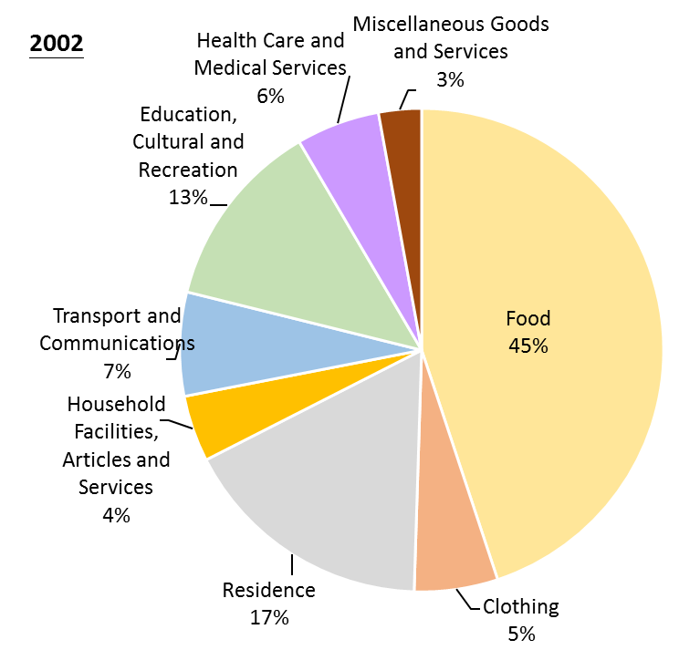 | 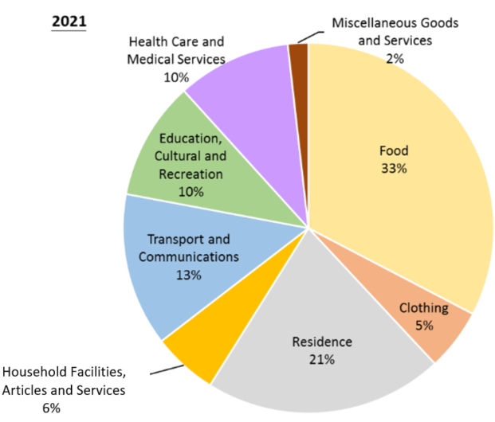
Source: China Statistical Yearbook (2021) China: National Bureau of Statistics http://www.stats.gov.cn/tjsj/ndsj/2021/indexeh.htm

  - According to Source 3, fill in the following form.

 | Item with the largest percentage increase in spending (percentage change) | Item with the largest percentage decrease in spending (percentage change)
Urban Area | Residence (10%) | Food (8%)
Rural Area | Transport and Communications (6%) | Food (12%)

Source 4: What does the change in the composition of consumption expenditure reflect?
Some economists pointed out that when the income of people in a place rises and the food demand is basically met, the focus of consumption will begin to shift to other areas. The decline in the proportion of expenditure on food to total consumption expenditure has declined reflect a rise in living standards in that place.

  - Challenge question: Based on the above information, analyse the changes in the living standards of urban and rural residents in the country over the past two decades.
Source 2 shows that the average annual income of urban and rural residents
in the Mainland has gradually increased over the past two decades. Source 3
also shows that in 2021, the proportion of expenditure on food to the total
consumption of urban and rural residents has decreased compared to 2000;
and according to Source 4, the living standards of our country’s urban and
rural residents have improved over the past twenty years.

The above information shows that the growth and development of our country’s economy over the past two decades has brought changes in jobs, increase in income, and changes in consumption patterns to urban and rural residents, all of which reflect an improvement of people’s living standards. In addition, other aspects of lives of Chinese residents have also benefited from our country’s economic progress. The following sections provide some online resources for students to learn on their own how the lives of Chinese residents have improved as a result of our country’s economic development.

Online Learning Resources
I. China Net: China’s National Conditions [Development Album]
Learning about the changes in the consumption patterns, travel patterns, living environment, and medical care of urban and rural residents in the Mainland since the reform and opening up through photos.

II. Teachers can ask students to browse the photos on the following webpage by themselves or they may replace them with other similar photos to reflect the differences in various aspects of urban and rural life in the Mainland.
- China Net: China’s National Conditions [Development Photo Album]
http://guoqing.china.com.cn/node_8007707.htm
- China Daily - Comparison of 40 years of reform and opening up: China in 1978 VS China in 2018
https://language.chinadaily.com.cn/a/201811/23/WS5bf74e82a310eff30328a888_2.html

The photos aim to reflect the differences in various aspects of urban and rural life in the Mainland. The teacher can remind students that life in many rural areas in the Mainland has greatly improved, and the photos only reflect the situation in some different rural areas. It is also suggested to invite students to find some photos of cities or rural areas in the Mainland, or photos of their own experience (such as photos taken by themselves during travel) for sharing in school, so as to show the diversity of lifestyles of Chinese residents in the Mainland. Teachers can also compare well-developed villages with less developed ones to explore the possible reasons for the differences in development. Additionally, teachers can pay attention to whether recent photographs that showcase our country’s economic development level and accomplishments are available to help students understand the current state of our country’s development.

Module 3.2 Overview of Our Country’s Economy and World Trade
Part 1: Economic Performance of Hong Kong
(Lesson 7)
Learning and Teaching Materials

Examples of national policies to improve people’s livelihood: Poverty alleviation policies

Introduction: Our country’s strategy of targeted poverty alleviation
Since 2013, the Central Government has proposed a targeted poverty alleviation strategy, with the overall goal of lifting the poor population across the country out of poverty by 2020. Targeted poverty alleviation refers to a method of poverty alleviation that uses scientific and effective procedures to implement accurate identification, accurate assistance, and accurate management in accordance with the environment of different poverty-stricken areas and the conditions of different poor rural households. Promoting the “Targeted Poverty Alleviation” strategy will help identify the poor and use the right method, making poverty alleviation more effective than ever.

Source: “Targeted Poverty Alleviation” Academy of Chinese Studies (2021)
https://ls.chiculture.org.hk/tc/hotopics/376?gclid=Cj0KCQiA0fr_BRDaARIsAABw4EvpsLYuRAwF7p91_7CShhRqCKGzLr_1AGfxE_nUdYJ_GgsCJRSshyUaAn2CEALw_wcB

 China Today EP17: How China has lifted people out of poverty, Our Hong Kong Foundation
(Length: 1 min. 30 seconds)
https://www.youtube.com/watch?app=desktop&v=QjTgj0m
This video briefly introduces the country’s poverty alleviation policy and uses the Atulie’er village (nicknamed “cliff village”) in Liangshan Yi Autonomous Prefecture, Sichuan Province, as an example to demonstrate the effectiveness of the policy.

Case Study: Guizhou Province
Source 1: Per capita disposable income and per capita consumption expenditure of all residents in Guizhou (2005-2021)

(Remark: Disposable Income of Residents refers to the income of residents for purpose of final expenditure and savings. It includes income both in cash and in kind. By sources of income, disposable income includes four categories: income from wages and salaries, net business income, net income from properties and net income from transfer.)

Source: National Bureau of Statistics‧ National Data (2022). “Basic Information on Income and Expenditure of All Residents” “People’s Livelihoods”

- Try to describe the changes in the per capita disposable income and per capita consumption expenditure of Guizhou residents during 2005-2021.
Both the per capita disposable income and per capita consumption expenditure
of Guizhou residents showed an upward trend from 2005 to 2021. Both the
per capita disposable income and per capita consumption expenditure in 2021
increased by more than five times compared to 2005.

Group activity: Let students watch the following videos in groups, complete Question 2 based on the videos they watched, and report the answers to the class.
Source 2: Measures for poverty alleviation in Guizhou Province
Video 1:
In Guizhou, in 1999, on the one hand, the government provided subsidies and grain; on the other hand, experts devised a plan to replace the formerly cultivated millet and buckwheat with higher economic value plants such as cherries, pipas, and red bayberries according to different terrains. After a few years, the local environment and farmers’ lives have improved.
Video source: China Today EP3: Effectiveness of China’s Restoring Farmland to Forest Program, Our China Story (Chinese version only )
https://www.ourchinastory.com/zh/1828

Video 2:
Since investing a lot in infrastructure development, the lives of people in Guizhou have greatly improved. After years of poverty alleviation, 55.75 million rural poor people across the country have been lifted out of poverty. According to the latest data in Guizhou, more than nine million people have been lifted out of poverty.
Video source: China Current: The Best in Guizhou (Chinese version only )
https://chinacurrent.com/story/20672/guizhous-war-on-poverty
Video 3:
Guizhou has a structural water shortage due to geographical factor, which directly limits economic and social development. The government solves this problem through water conservancy projects.
Video source：China Current─Why is it difficult to keep water in Guizhou? (Chinese version only)
https://chinacurrent.com/education/article/2022/08/23867.html

- Based on the video contents above, complete the table below.
Video | Environmental factors leading to poverty | Targeted poverty alleviation measures | How the measures help local residents
1 | The rocky desertification of the karst landform is serious. Villagers farm on the barren land, but the productivity is low and the environment is deteriorating rapidly. | In 1999, the government on the one hand provided subsidies and food, and on the other hand, experts designed a plan to replant plants with higher economic value according to different terrains. | The vegetation coverage rate has increased from about 10% to 90%, and the per capita income has also increased from about 1,000 RMB to 10,000 RMB.
2 | There are no plains in the whole province, and more than 90% of the area is mountainous, resulting in isolation from the outside world. | Measure 1:  Build a number of bridges, highways, and tunnels to connect Guizhou with other places. | With the opening up of transportation to the outside world, the living and economic environments of the people of Guizhou have been greatly improved due to the massive investment in infrastructure in recent years.
2 |  | Measure 2:  Relocation for poverty alleviation and relocation by assisting poor households living in isolation to get out of the mountains. | Residents have housing, jobs, training, and schooling opportunities.
3 | Mountains and hills in Guizhou account for 93% of the country's land area. It is a typical karst mountainous area with high mountains and steep slopes, and it is difficult to retain water. | Measure 1: Construct water diversion facilities and pipelines for long-distance water transportation. | Meet the needs of drinking water in the rural area and farmland irrigation along the line of water facilities.
3 |  | Measure 2: Establish a vegetable growing base for the relocated poor residents to find jobs nearby. | About 200,000 poor households had increased income.

- Referring to the online information provided by the Hong Kong Trade Development Council (see website below), describe the changes in the industrial structure of Guizhou province from 1980 to 2021.
Website: https://research.hktdc.com/en/data-and-profiles/mcpc/provinces/guizhou
The percentage of Guizhou's primary and secondary industries in the region's
total GDP has continued to decline from 1980 to 2021, with a larger decline in
the primary industry, which fell from 41.3% in 1980 to 13.9% in 2021.
Meanwhile, the tertiary industry has risen during the same period, from 18.9%
in 1980 to 50.4% in 2021.

References
World Bank
https://data.worldbank.org/

National Bureau of Statistics
http://www.stats.gov.cn/english/

China Net
http://guoqing.china.com.cn/

Academy of Chinese Studies
https://ls.chiculture.org.hk

Our China Story
https://www.ourchinastory.com/en/home

China Current
https://chinacurrent.com/



